**USE of Super keyword**

class A:

def first_method(self):

print("Method of class A...")

class B(A):

def first_method(self):

print("Method of class B...")

super().first_method()

ob=B()

ob.first_method()

**OUTPUT**

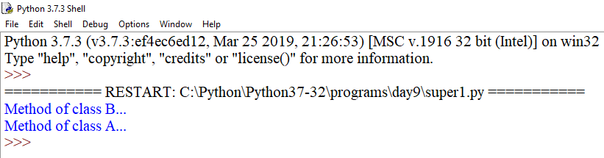

class A:

def first_method(self):

print("Method of class A...")

class B(A):

def first_method(self):

print("Method of class B...")

class C(B):

def first_method(self):

print("Method of class C1...")

def third_method(self):

print("Method of class C2...")

super().first_method()

if __name__=="__main__":

ob=C()

ob.third_method()

**OUTPUT**

